**Assignment No.: 06**

**Problem Statement:** **Upload a static website on S3.**

**Solution Process:**

**Steps:**

1.Create a public bucket and name the bucket and also change the object ownership info, and change the Block Public access settings for the named bucket.

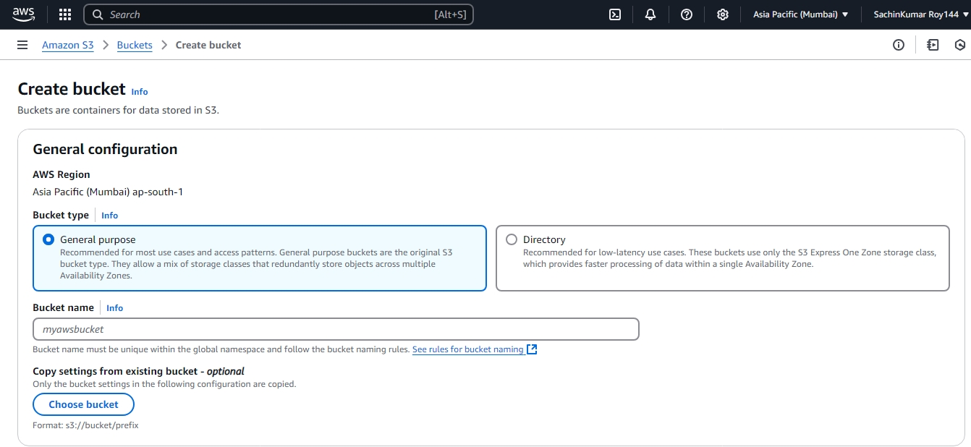

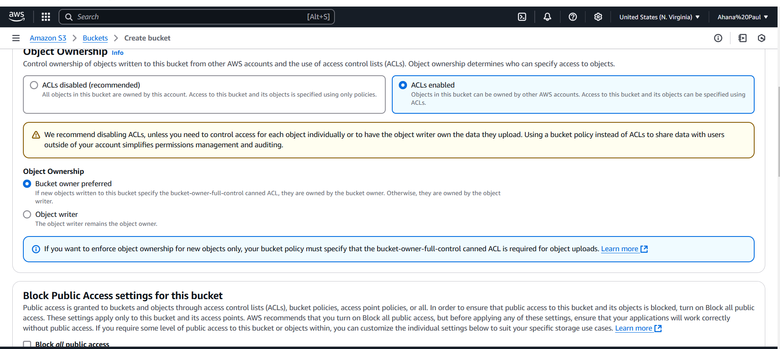

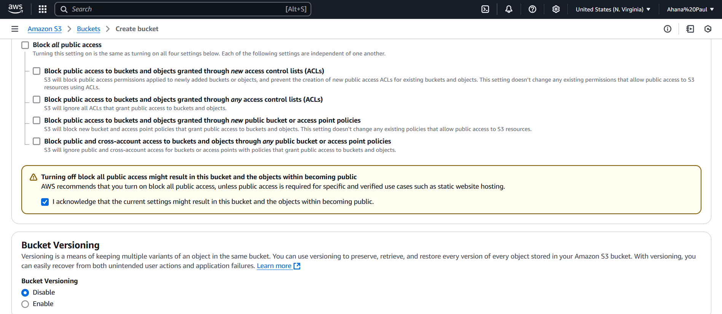

2: The bucket is successfully created.

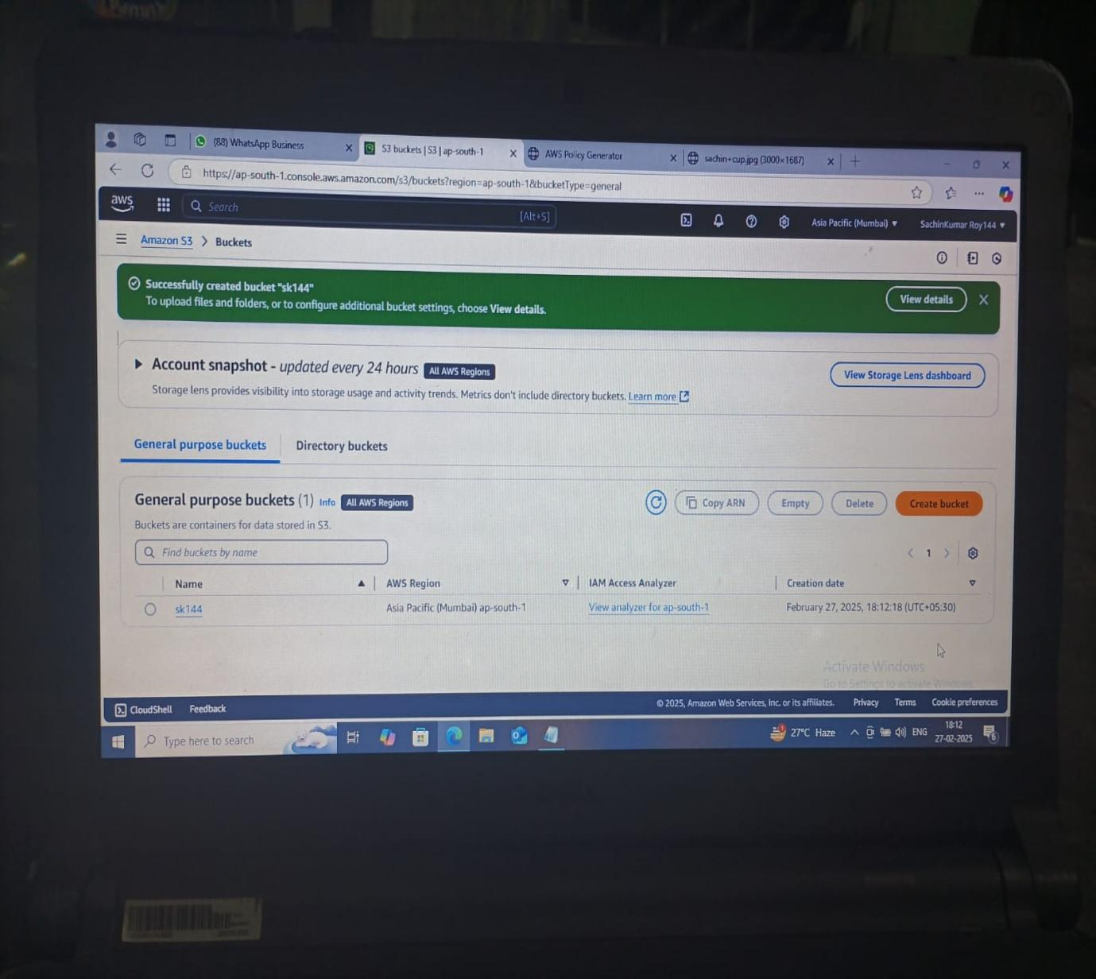

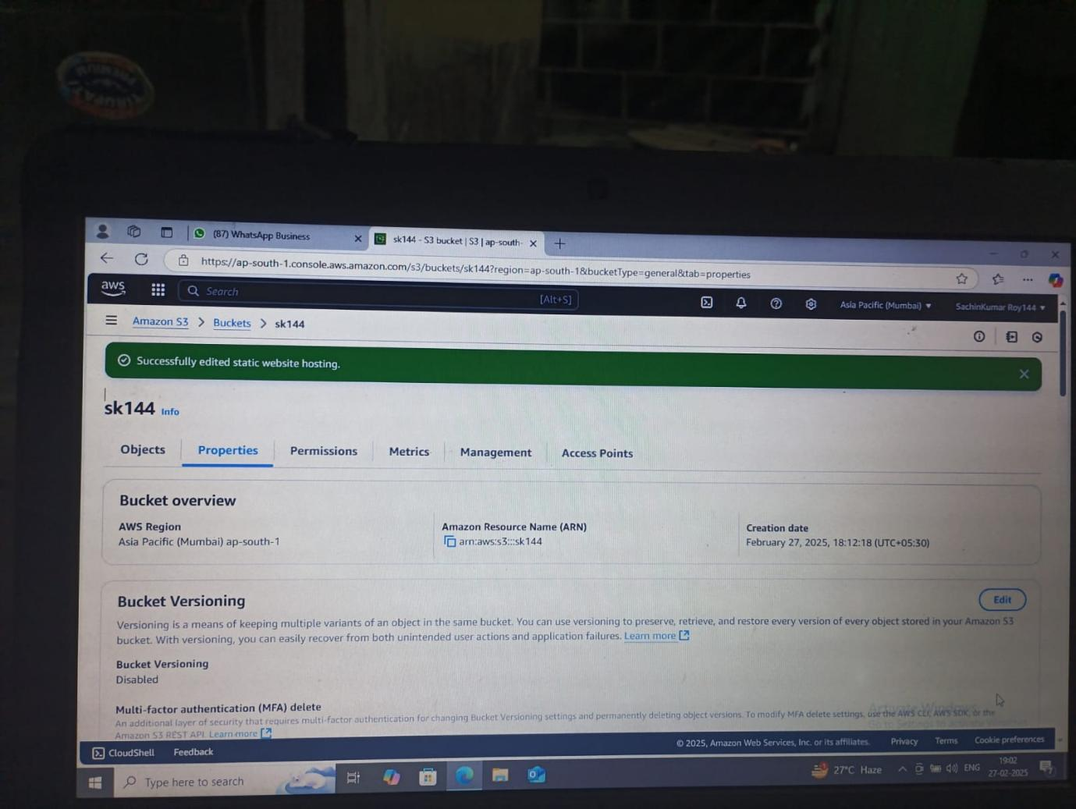

3. Then go to bucket permission and edit the ACL option.

4. Choose everyone row and tick on the list and read box and save this.

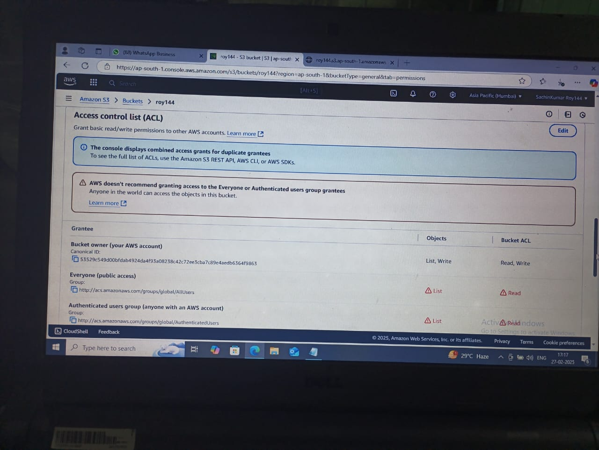

5. Create 3 html file connected each other, then those 3 files are upload in the created

public bucket.

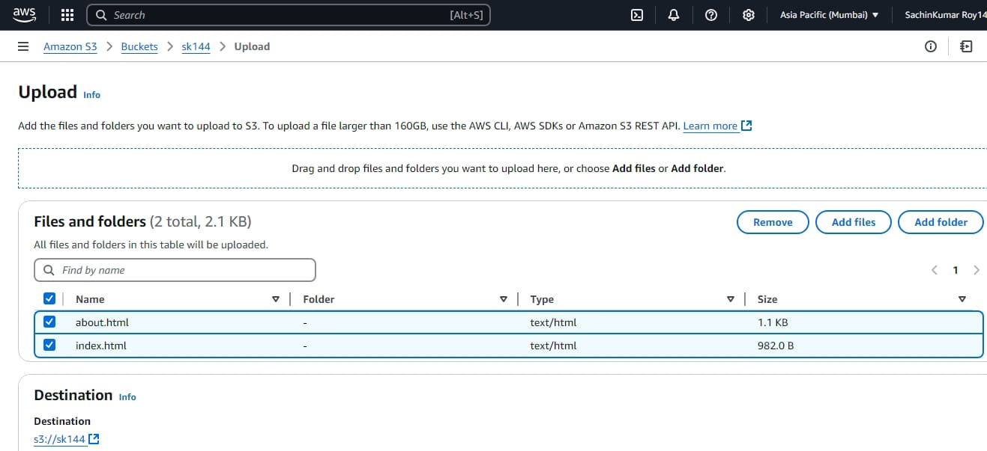

6. In the file’s permission gave the access to ‘Specify individual ACL permissions.

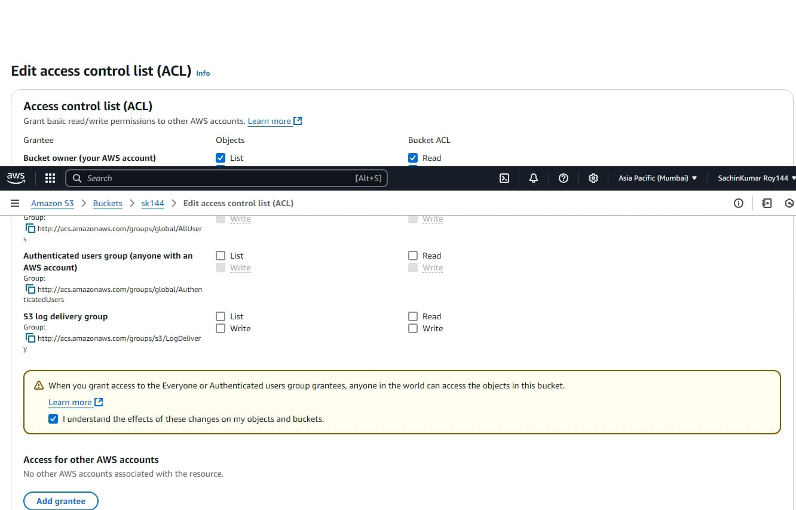

7. Go to the Static Website Hosting and enable this option.

8. Then give the index document name and save this.

